

**Semester 1**

**Economic Analysis with Matrices (ECO2048)**

**Report**

Participants:

Christian Cheng (6467665)

James Patterson (6513204)

Tom Parry (6495610)

Sam Crofts (6510435)

Mark Contributions:

Christian Cheng – 23%

James Patterson – 23%

Tom Parry – 23%

Sam Crofts – 31%

**Project Overview:**

This project is a Zombie Apocalypse Dice Roll Game which involves numerous levels with 2 choices at each stage. Each choice creates a different outcome and can lead you down a safe or dangerous path through the zombie attack. You begin at the home screen where there is a ‘how to play’ option which gives you a brief explanation on how the game works. Once you press ‘let’s go!’, you choose your difficulty. During this apocalypse, you and the zombie start off with 100HP (health points) each. During the game, you can attack the zombie by selecting the correct choice. If you select easy mode, you gain +1 strength which increases your attack points giving you an advantage. In medium you neither gain nor lose (+0) and in hard mode, you lose -1 strength. When you’ve chosen your difficulty, the game begins, and the first choice appears. If you choose the correct choice, you attack the zombie whilst also increasing yours by +20. A wrong choice, the zombie will gain +20HP. These choices are presented in the text, but the player doesn’t know which one A or B is. After each chosen answer, there is a dice roll which will be explained later in the report where 2 dies are rolled, one for you and one for the zombie. If you roll greater, the zombie takes damage and vice versa. If the numbers are equal, no one takes damage. There is a maximum of 6 rounds. At the end of the six rounds, the player with the most health wins and defeats the opposition.

**Motivation:**

We chose to create a project that had entertainment value, and that offered something different to the standard report that was also an option for the project. Our motivation was therefore in part due to the fun and entertaining nature of video games and zombies, as well as the determination to attempt something slightly different from the norm. When planning our initial ideas, the game provided us with scope to use a variety of features and opportunities that MATLAB had to offer in order to utilise some of the groundwork put in place over the course of the semester. To begin with, this centred around basic syntax such as using a series of IF statements to guide the user through the game, being offered choices through a GUI created through the GUIDE module. In addition to this, the core idea of a choice centred game provided us with ample opportunity to add complexity to the code, for example incorporating mp3 files into the code for ambient music and using a matrix to contain the different stages the player can progress through to get to one of the endings of the game.

On top of this, to focus more on the GUIDE module we felt that the game would present the best chance to learn the basics of GUI production in MATLAB, as there were many reasons why a GUI would suit this project; the game becomes a significant amount more entertaining for starters, as well as simplifying the decision the user has to make at each stage of the game. Other coding practises that are accommodated by creating a game included the use of global variables across the entire programme to help tie together the different pieces of code involved in the project.

**Code:**

To run the code and play the game, you need the files ‘homescreen.m’ and ‘levelb’ which are files found in our code submission. You open these on MATLAB and run the code. We used GUIs to create the buttons from the home screen and playing screens. The ‘howtoplay’ file gives you instructions on how to play the game which can be found from the GUI at the start screen of the game.

All levels of the game have the same structure of coding adjusted to the different choices. When selecting a choice for example selecting choice A, the code will get rid of both choices and display the text corresponding to the chosen choice i.e. Text B and the choices that come with this text, a and b. The code also displays the effect of the dice roll on yours and the zombies attacks. If you win the game, the code ‘winscreen2 .m’ takes you to the winning screen and if you lose, the code ‘losescreen’ takes you to the losing screen.

To code in the music, we used ‘audioread’ to start the music and ‘clear sound’ to stop the music when you move between GUIs.

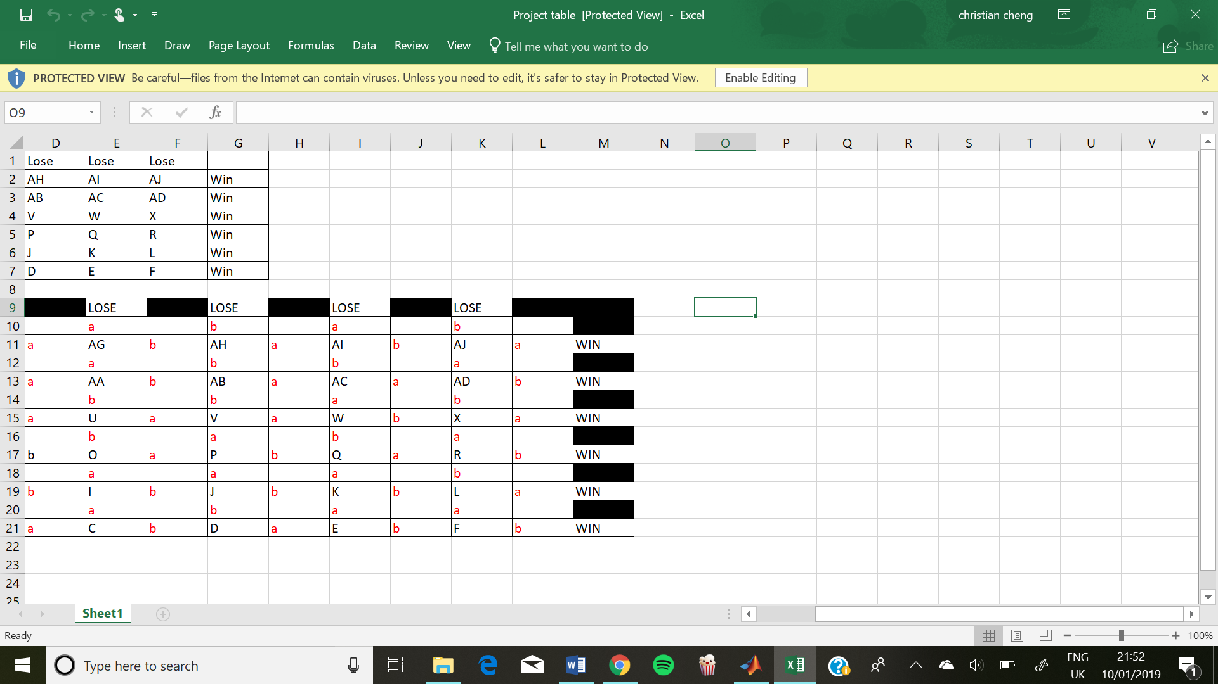**Cheat Sheet:**

The small letters in red indicate the possible choices the player can make whereas the capital letters in black are the storyline in the large textboxes.

To make the game more exciting, you should choose the choices along the bottom horizontal row or the choices along the left vertical column. These are the situations with a story line.

**What we could do differently:**

In terms of any differences we would implement upon doing the project again, the consensus within the group is that the game could have been longer, with more options and a more fleshed out story. Whilst the game is currently of an adequate length and there is a small element of storytelling and writing involved with the game, to fully fulfil the vision that was detailed upon the inception of the game the user would need to be presented with some writing at every stage, as well as the introduction of other characters to include some emotional investment – this could perhaps be achieved by adapting the progression system in the game in terms of moving towards the endings to a more linear model.

Another issue with the game that could be improved upon next time would be making it more challenging. To do this, potentially higher stakes could be introduced at each stage. Currently the user can lose 20 health points at each stage should they make an ‘incorrect’ decision and move upwards on the stage map. This could be changed by introducing stages at random which involve player death events, or two choices with differing probabilities to bring in an element of risk to the game, increasing both excitement and replay value.

We would also include more story in our game, as only 2 specific pathways will give you a full story line, rather than ‘Attack or Dodge’ to make it more interactive and interesting for the player.